**LAB SESSION # 07**

**Q1.** 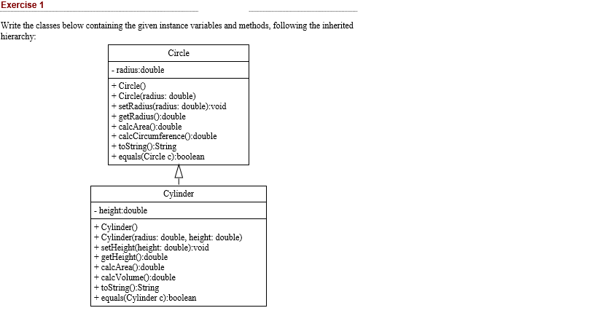

**INPUT**

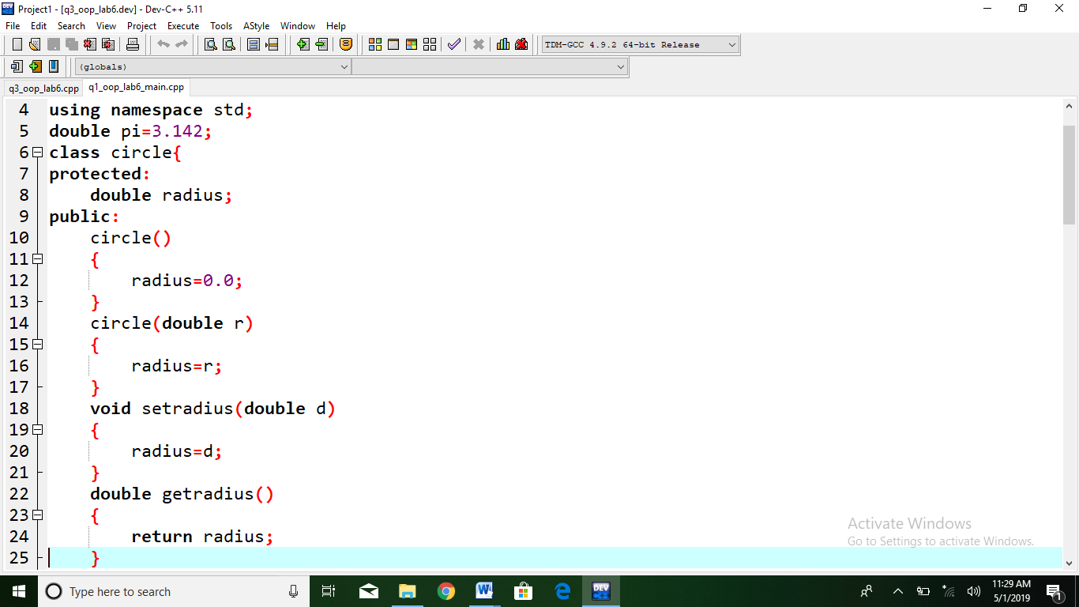

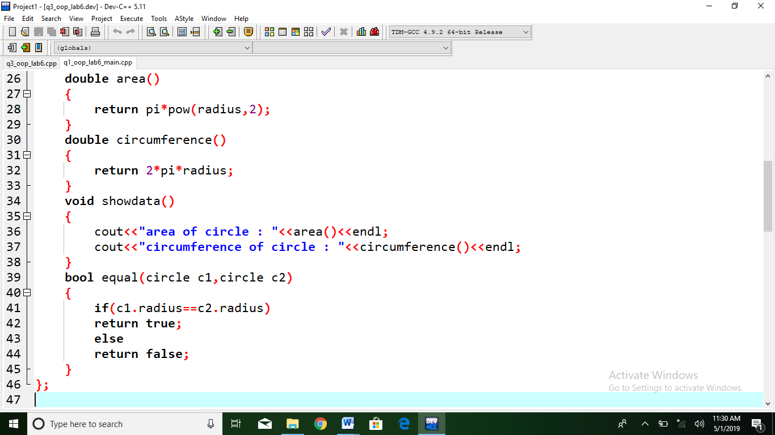

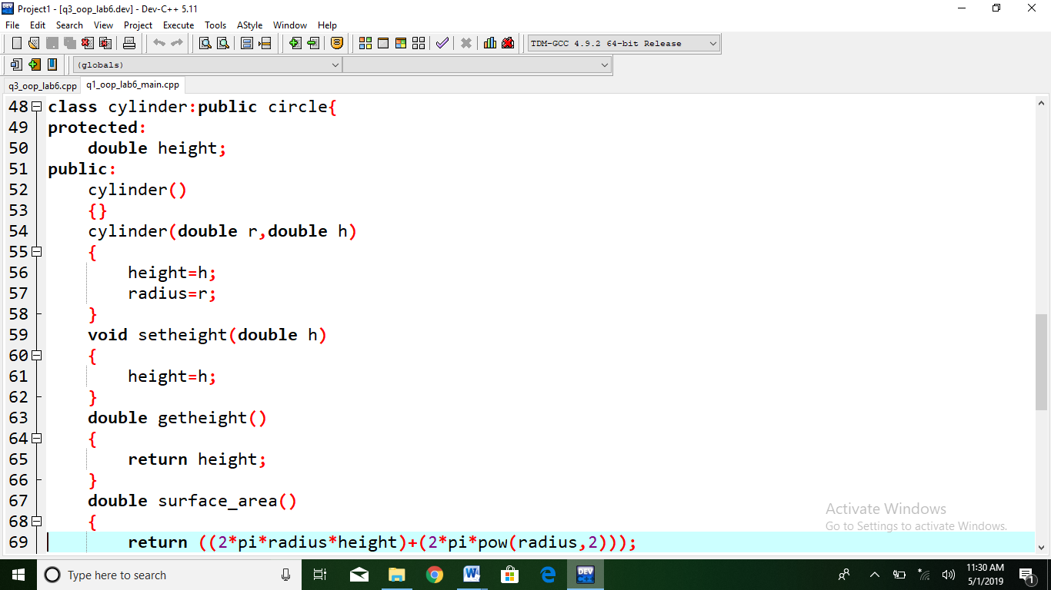

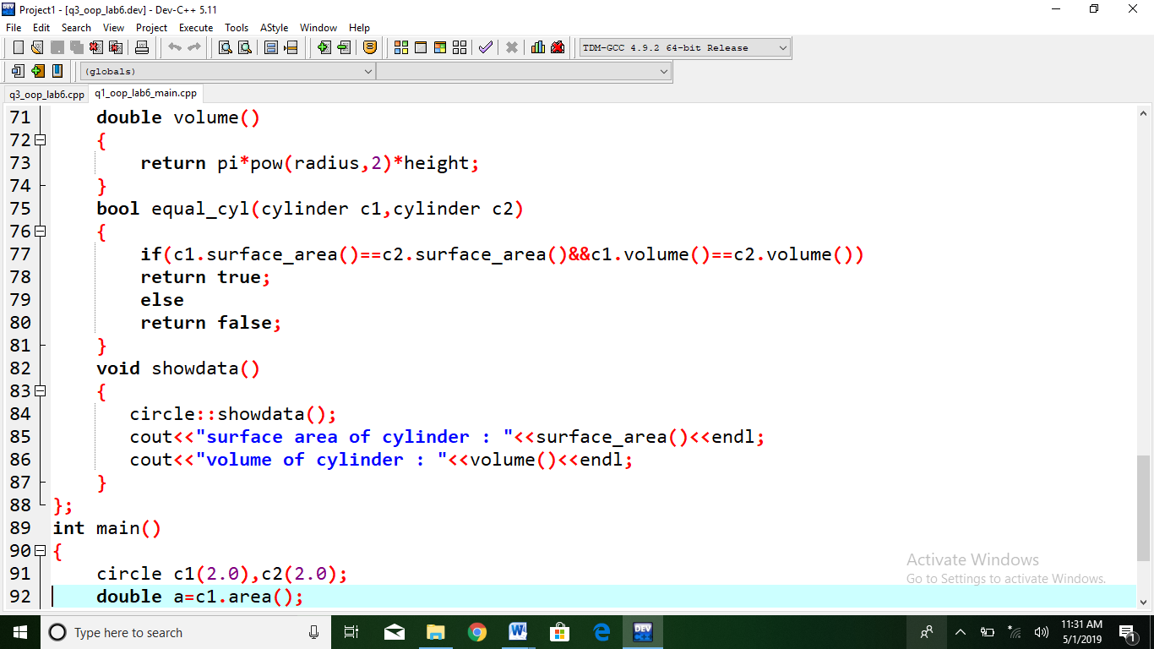

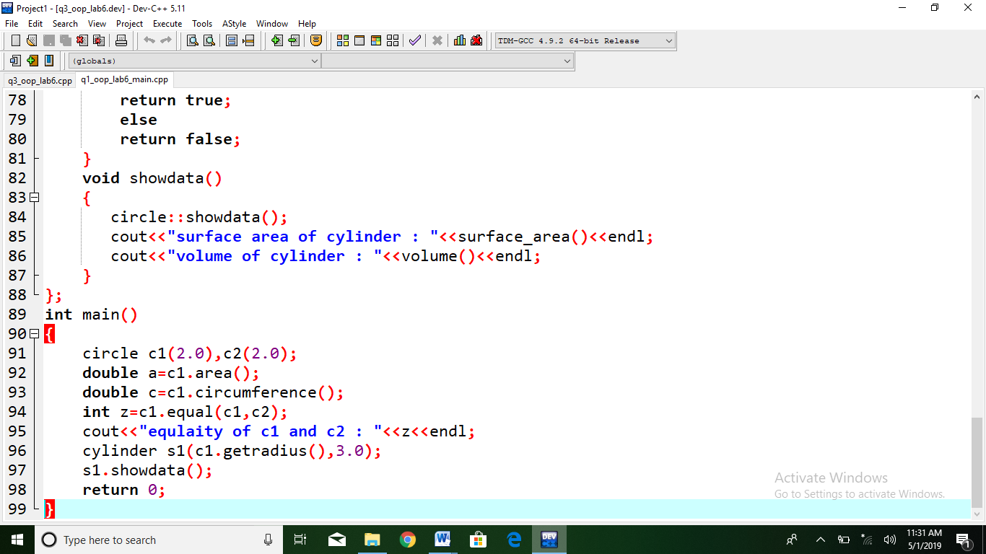

**OUTPUT**

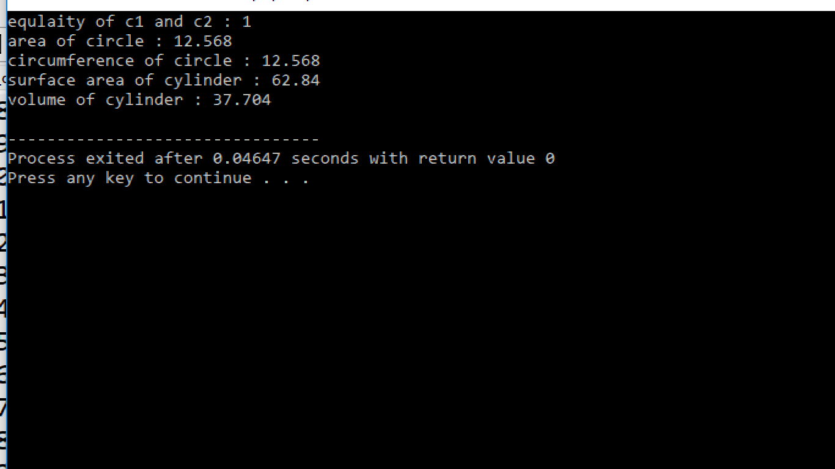

**Q2. Create Box class containing data members (width ,height,Length) and Member functions showdata and Volume.. Apple the concept of Operator Overloading and overload operators (+,-,* ,/) for addition subtraction multiplication and division of Objects of Box class.**

**INPUT**

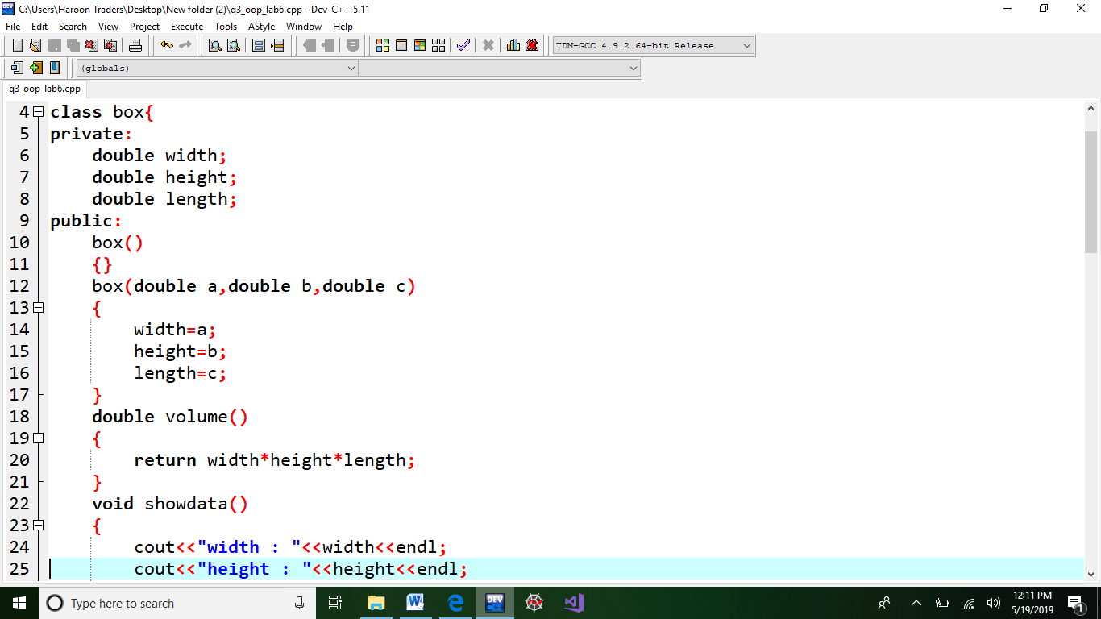

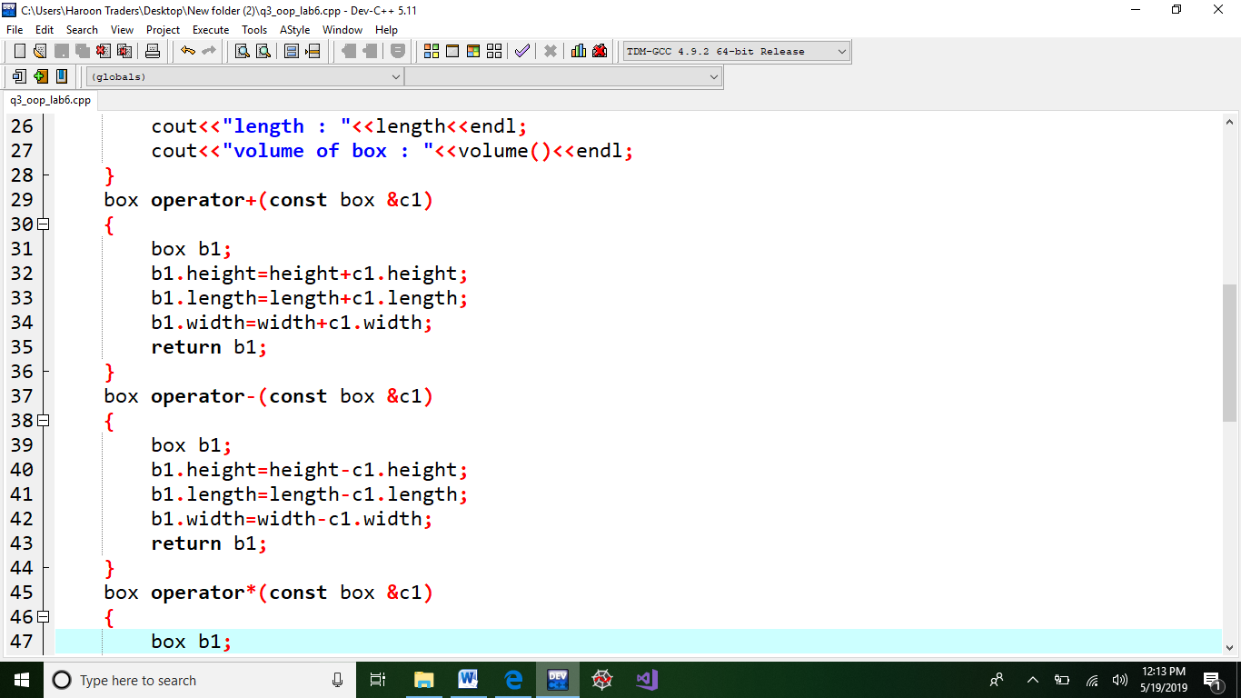

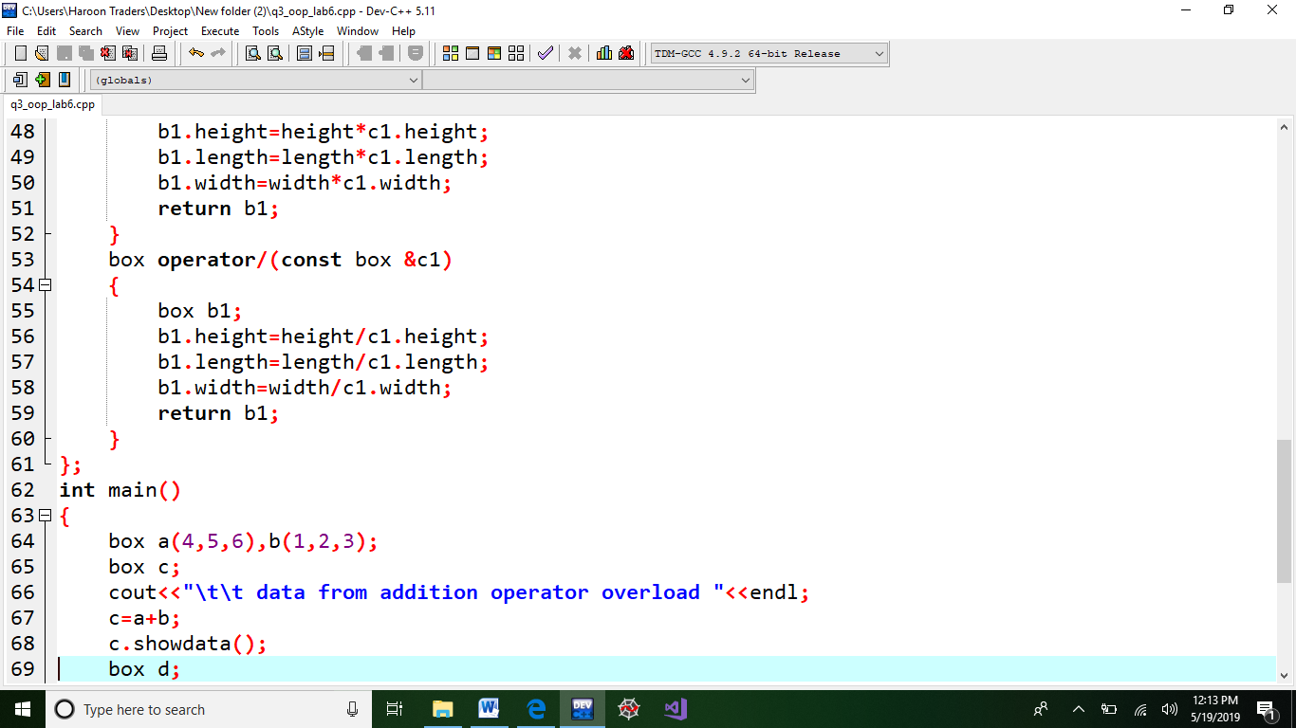

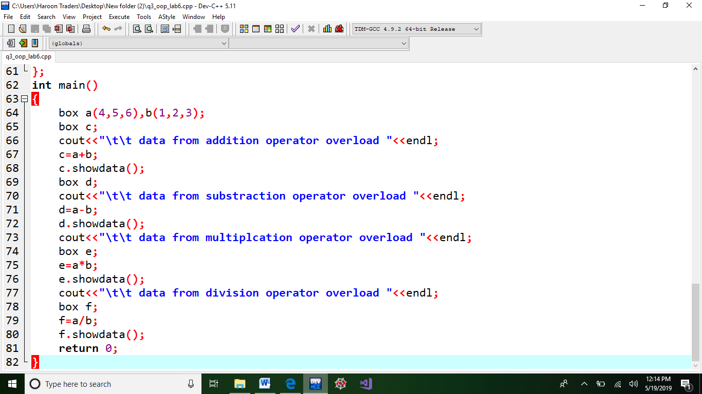

**OUTPUT**

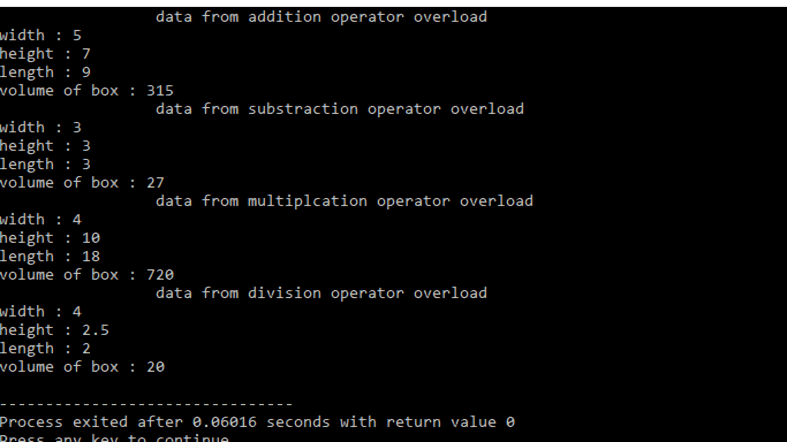

**Q3 . Apply the Concept of Composition by Creating part classes(doors,windows,Engine,Wheels) and than . Create a whole class Car that is composed of all these defined parts.**

**INPUT**

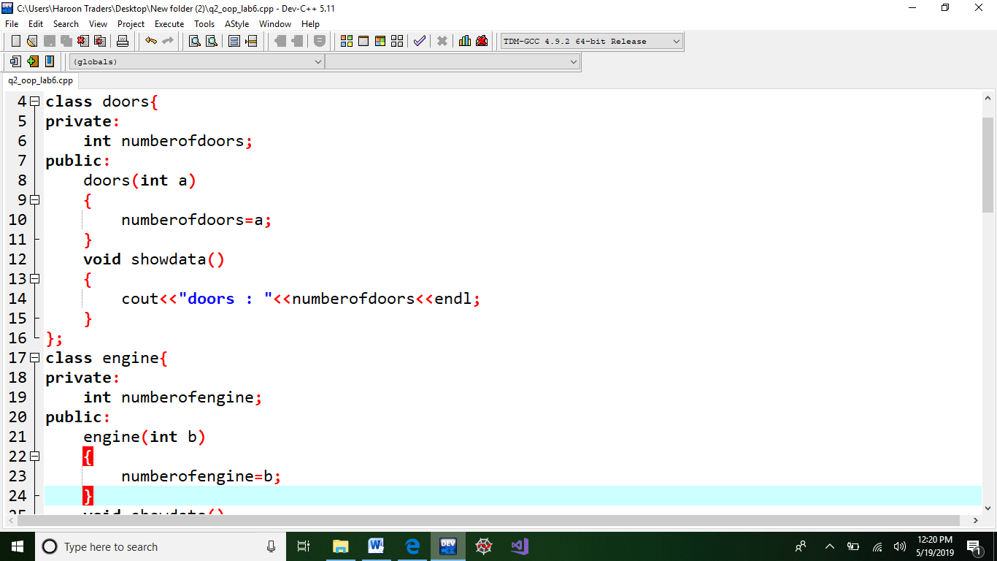

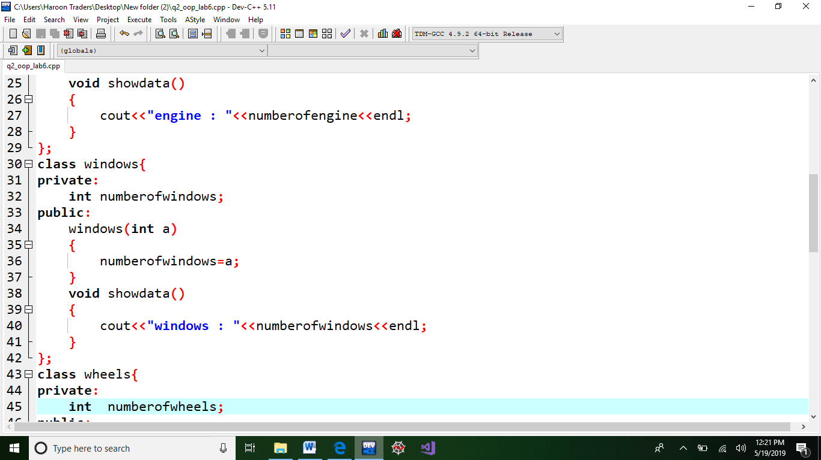

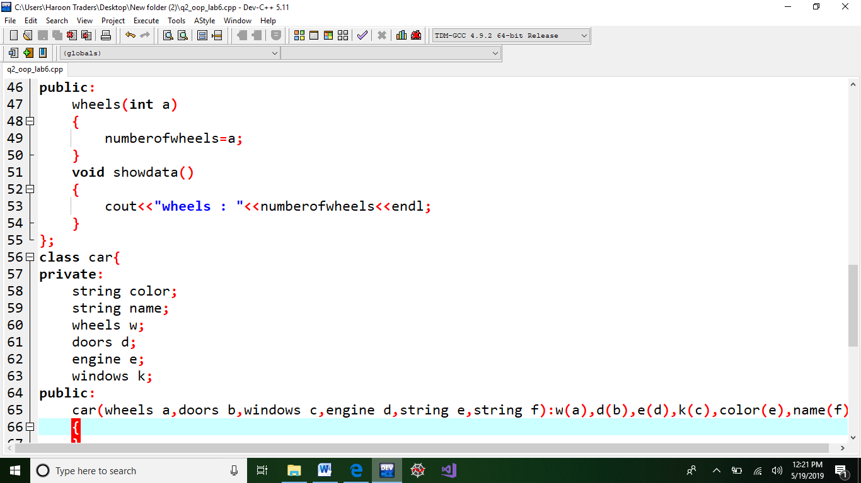

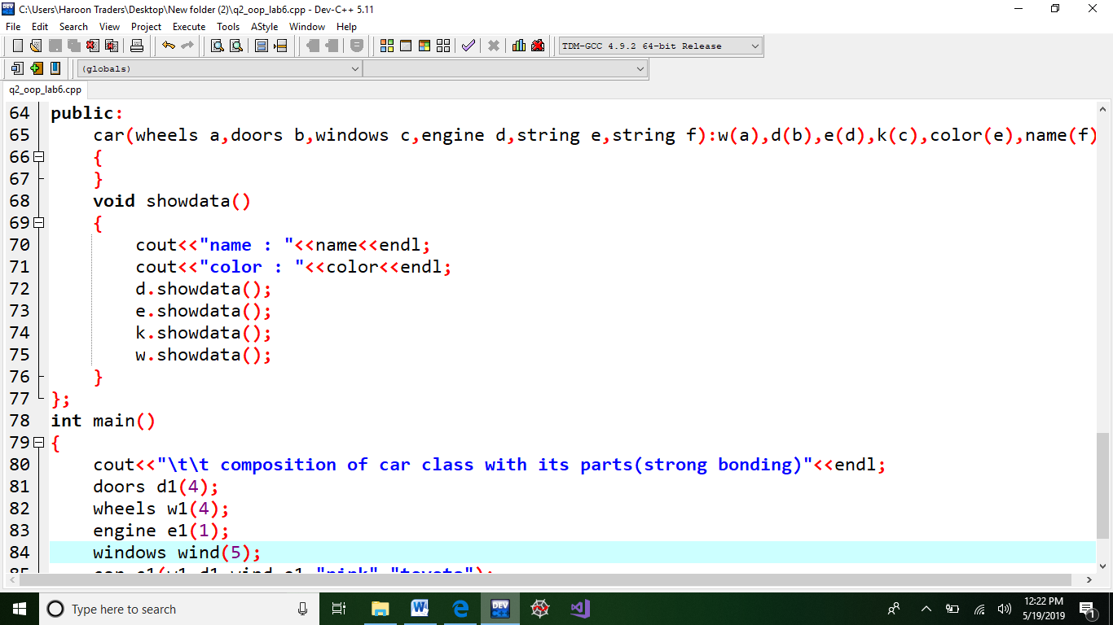

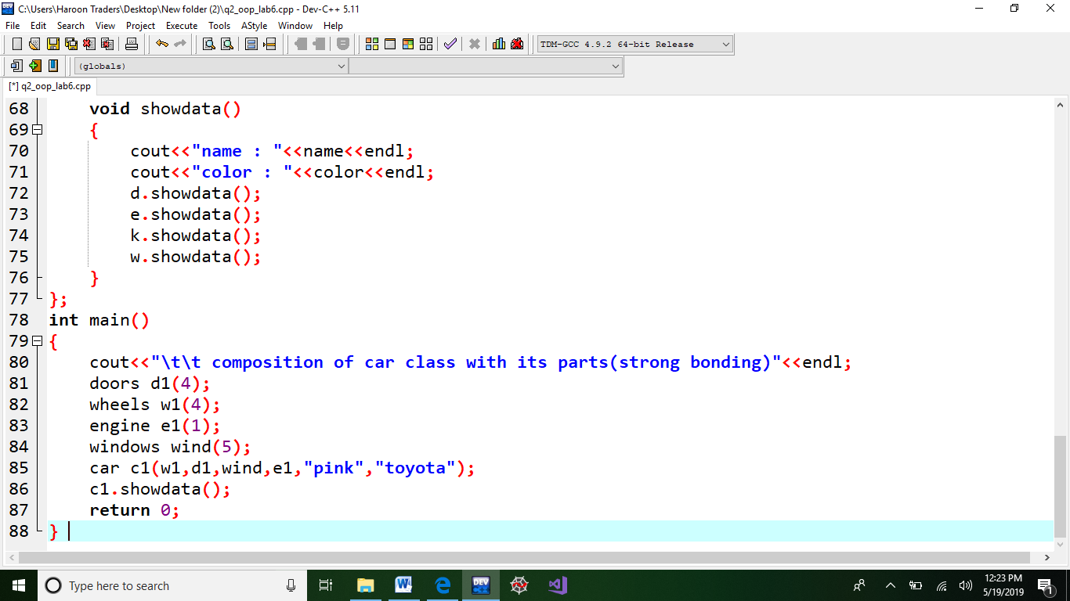

**OUTPUT**

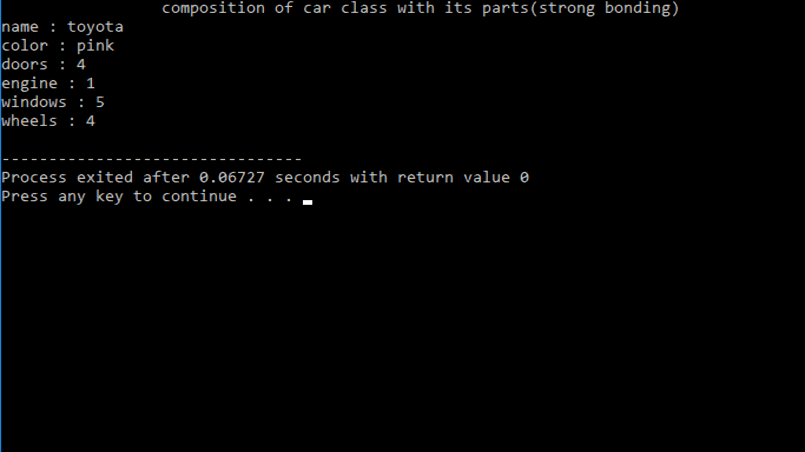

**PREPARED BY: MUHAMMAD FARAZ ANSAR (Se-061).**

**Course instructor: miss asma khan.**